Intensified Tuberculosis (TB) Surveillance in Computed Tomography (CT) scan centres across Karnataka.
COVID-19 pandemic has affected key strategic interventions of TB program particularly notifications resulting in almost 28% decline in TB case notification in 2020 as compared to 2019. The ongoing 2nd wave COVID-19 pandemic continue to disrupt the TB notification. Decline in TB notification may lead to significant morbidity and mortality, and an increased likelihood of active transmission in the household and close contacts.

Radiological tools were widely used to screen the symptomatic patients for TB. It is observed that High Resolution CT(HRCT) Thorax scans have been drastically increased during the 2nd wave of COVID-19 pandemic and there were great opportunities to find the missing TB patients in CT scan-based surveillance due to high sensitivity and specificity of CT scan to rule in or rule out Tuberculosis. Hence, to revive the TB case finding activities during the pandemic, CT scan-based surveillance was started off as pilot in Belagavi and Gulbarga districts of Karnataka and later scaled up to all the districts of Karnatka.

Description of the model
The activity was as follows

- line lists of the patients where CT scan suggestive of TB were collected from all the CT scan centres of the districts and all such patients identified through CT scan centres were enrolled in the NIKSHAY as presumptive TB patients.
- These presumptive TB patients were mobilized for offering TB diagnosis through TrueNat/CBNAAT.
- if tested positive or MTB detected, they were managed as per the existing NTEP guidelines and if tested negative, then clinical opinion was taken to diagnose other causes or clinically diagnosed Tuberculosis.
- The existing trained TB program staffs are being involved in the activity with no additional costs on the health system.

The activity got implemented in the pan state from 26th May 2021 and weekly data was collected and results of the same is as follows
- Throughout Karnataka about 324 CT scan centres were identified and our NTEP key staff of the respective areas were entrusted with the responsibility to collect the report weekly and enter in the google spreadsheet created so that reports could be compiled at district level and then submitted to state.
- Through this new intervention state was able to identify 1243 presumptive TB patients and notify 361 TB cases till date.

TB surveillance in CT scan centers across the state and its findings from 26th May -29th October 2021
 | No of CT Scan centres | Number of Presumptive TB patients identified | No of TB patients microbiologically confirmed | No of TB patients clinically diagnosed | Total TB diagnosed
Karnataka | 324 | 1243 | 147 (12%) | 214 (17%) | 361 (29%)

NTEP key staff visiting CT scan centers for collecting line list of presumptive TB patients
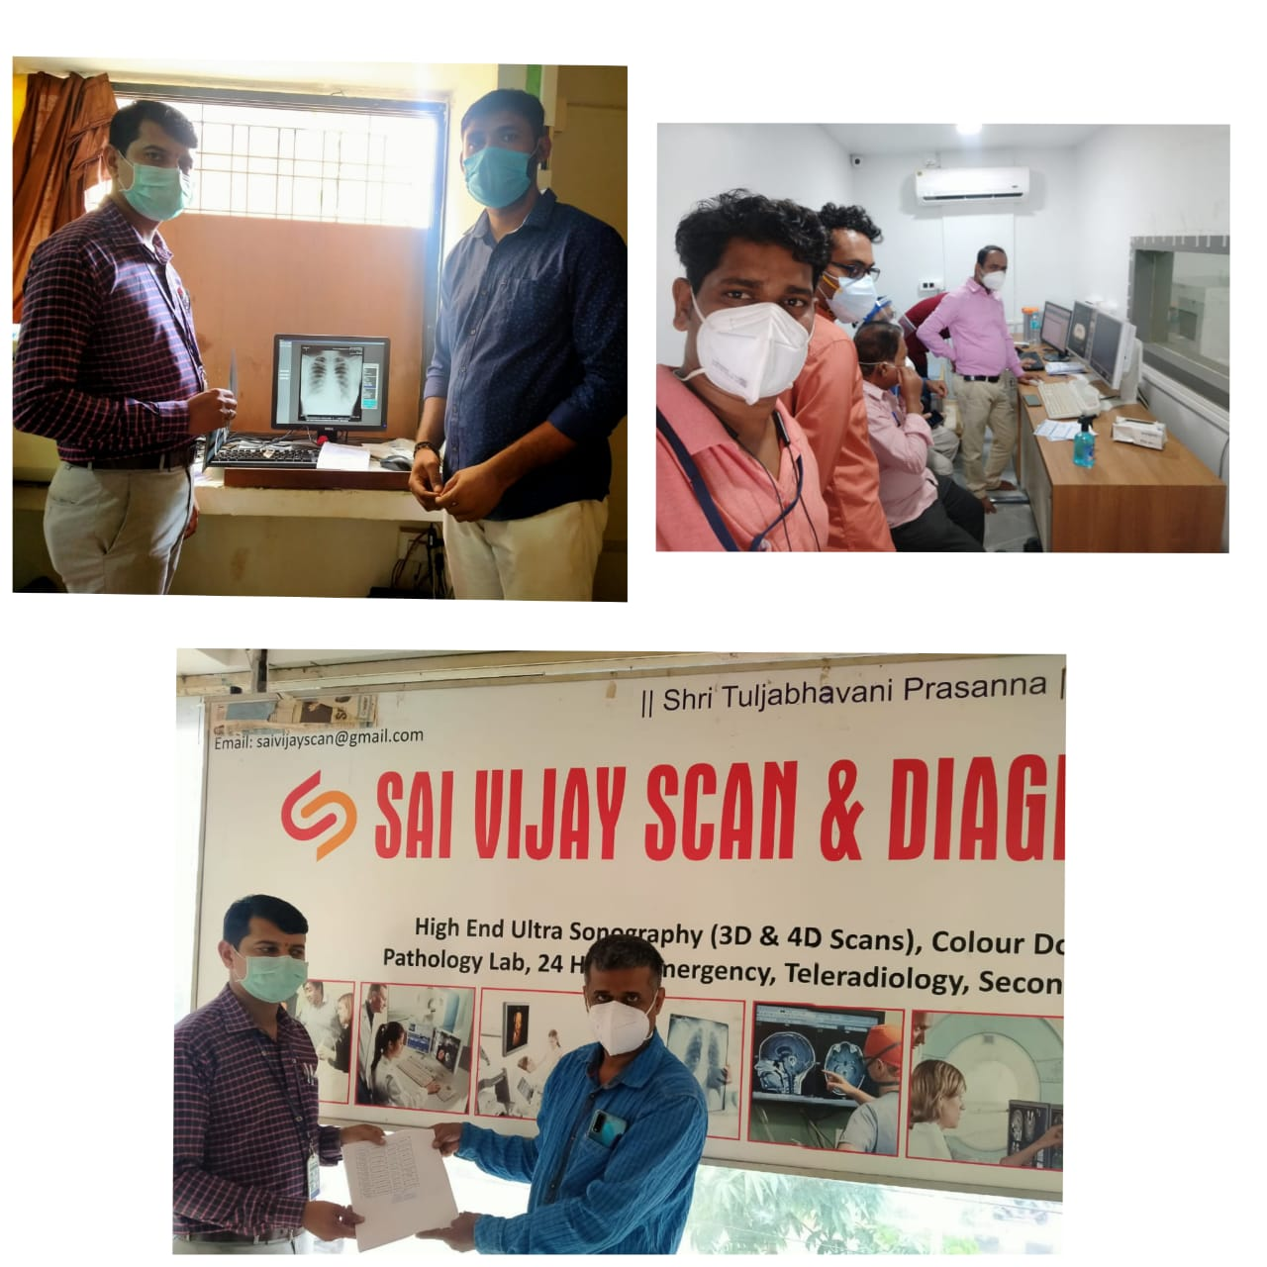

This innovative activity has shown that CT scan/image-based surveillance for Tuberculosis during the COVID-19 times has been useful and this practice can be adopted as additional activity in routine TB surveillance by engaging the CT scan centres and further actions shall follow the National TB Elimination Program guidelines.

