Response towards TB Care during COVID 19 Emergency Situation
Assam

Emergence of the Covid-19 pandemic across the world necessitated all the states to take pro-active measures and innovations to overcome the bottle-necks and ensuring un-interrupted service delivery for the TB patients and Assam State was not an exception as the state took some innovative approaches during this hour of crisis.
Building on the Advisories in the form of DO letter from Central TB Division, Govt of India following measures were undertaken by the state:
- Dissemination of the advisories among all the districts
- Periodic Video Conference through ECHO platform to review various activities
- Stock analysis of drugs, CBNAAT cartridges and laboratory materials
- Drug stock analysis in the districts against the existing number of patients to ensure availability of at least 2 months stock of drugs in districts during the lock-down period

- Ensuring un-interrupted drug supply for the existing TB patients:
Following a Video Conference conducted with all districts for disseminating the directives from GoI, all districts initiated the process of ensuring drug supplies for the existing 20,000 (approx.) no of patients adopting various mechanisms such as home delivery of the drugs by NTEP staffs including DTOs and through community volunteers including ASHAs. Officials vehicles of DTOs/ MOTCs / STS / STLS were engaged for supplying ATT to the patients and Govt pass for staffs and vehicles were provided to the staffs for movement within the district for ensuring drug supplies.

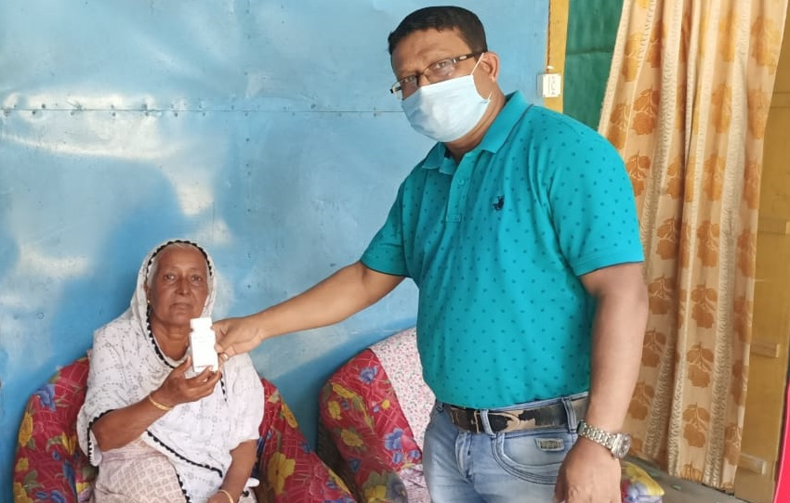
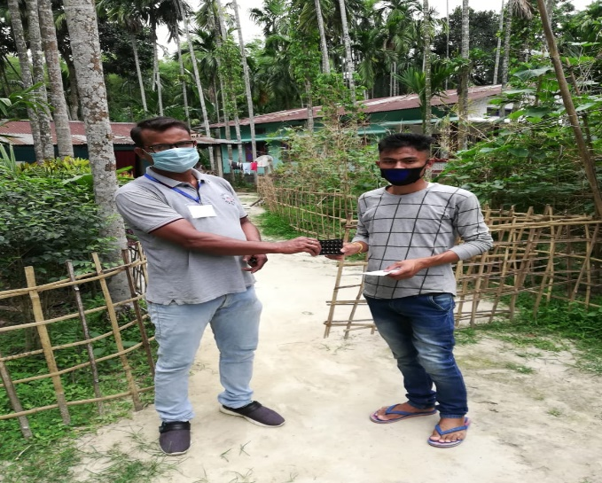

Ensuring uninterrupted provision of ATT to TB patient residence by DTO (Morigaon) and STS (Sonitpur)

- Sample Collection & Transportation for Universal DST and LPA:
Following the VC on 8th April’20, districts were clubbed for arranging transportation of samples for LPA to IRL and also for collecting drugs from State Drug Store in Guwahati. This approach ensured not only sample transportation for LPA but also ensuring drug collection and delivery to the districts. Sample collection and transportation in the districts were facilitated not only by the STS, STLS, TB-HVs, LTs but also by the NTEP drivers during the lock-down period.

Period | No of samples received for Diagnosis  (LPA + CBNAAT) | No of samples received for Follow-up at IRL | Remarks
Jan’20 | 671 | 159
Feb’20 | 505 | 141
Mar’20 | 641 | 93 | No samples were received after lock-down from 24th March
Apr’20 | 226 | 34 | IRL started receiving samples from districts from 10th April following the VC

- DR-TB service at doorstep
An unique example of dedication of a District PMDT Coordinator of Dibrugarh district, he visited the residence of a bed-ridden DR-TB patient and conducted bed-side ECG on the patient and collected blood samples for pre-treatment investigations and the patient is currently on domiciliary treatment.
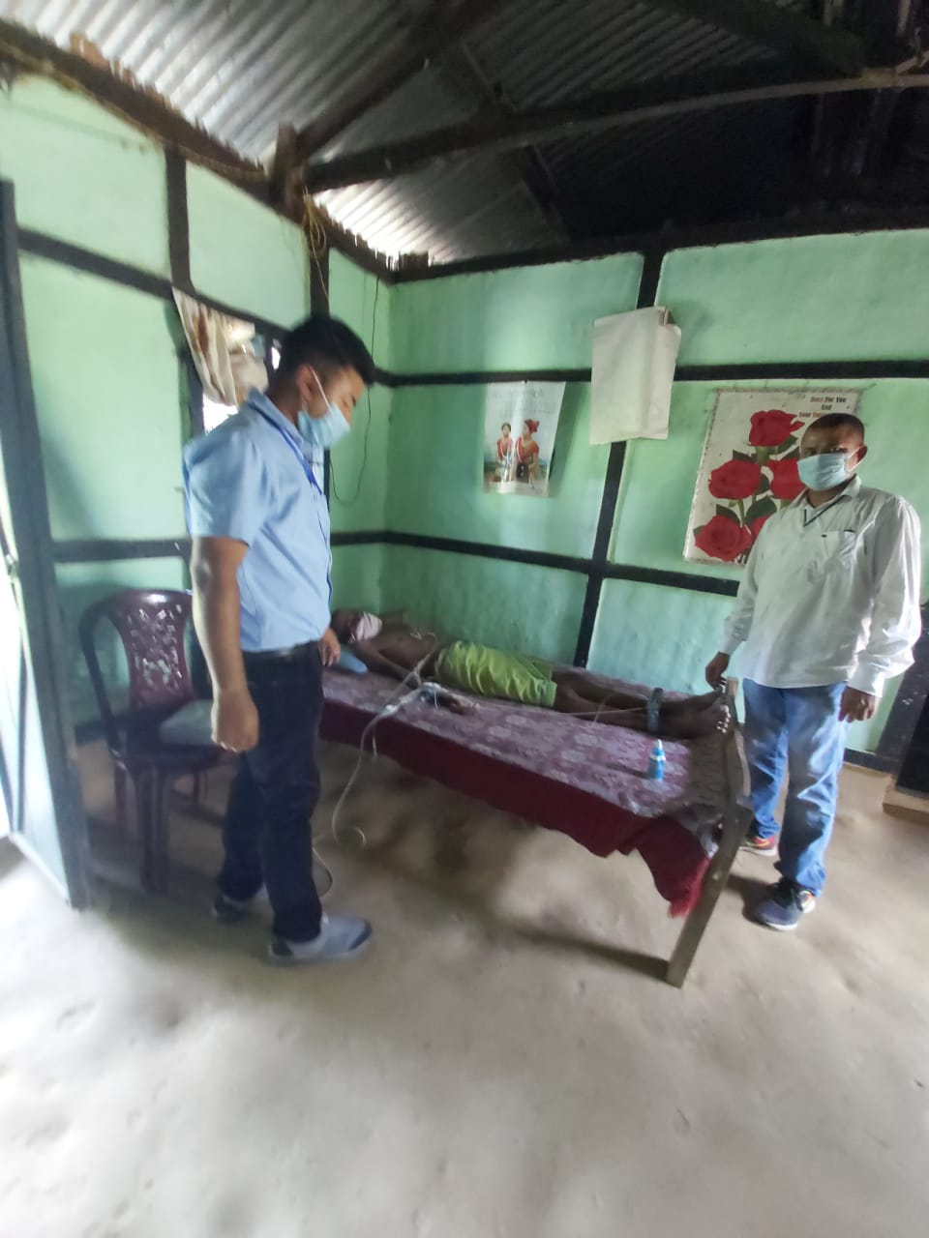

PMDT Co-ordinator of Dibrugarh district providing bed-side service for a bed-ridden DRTB patients

- Telephonic follow-up and counselling of TB Patients (Supplemented by Partners):

To overcome the issue of one to one follow-up and counselling of the TB patients during the on-going lock-down period, support of the existing staffs under JEET project were also garnered to supplement the efforts of the NTEP staffs. A VC was conducted with all districts in presence of officials and staffs of JEET project staffs wherein mechanism were worked out to collect list of TB patients from difficult to reach areas (TB Units / PHIs) which was shared with the JEET project officials and staffs irrespective of their jurisdiction. JEET State Lead as per direction and guidance of STO, WHO Consultants and state team planned a strategy to follow-up and counsel TB patients over telephone involving 43 staffs of JEET project.
Following telephonic counselling, patients who were facing difficulties in accessing drugs were linked to their respective STS and nearest PHIs for ensuring drug supply for at least a month. This service was offered to both public and private patients. Many districts also sensitized ASHA workers to visit TB patients during the COVID 19 locked down period for counselling and supervise TB treatment. The JEET team could reach to ~ 2500 TB patients since 11th April’20 till date and still continuing.

- Activities of State and District TB Cell team during Covid-19 lock-down period

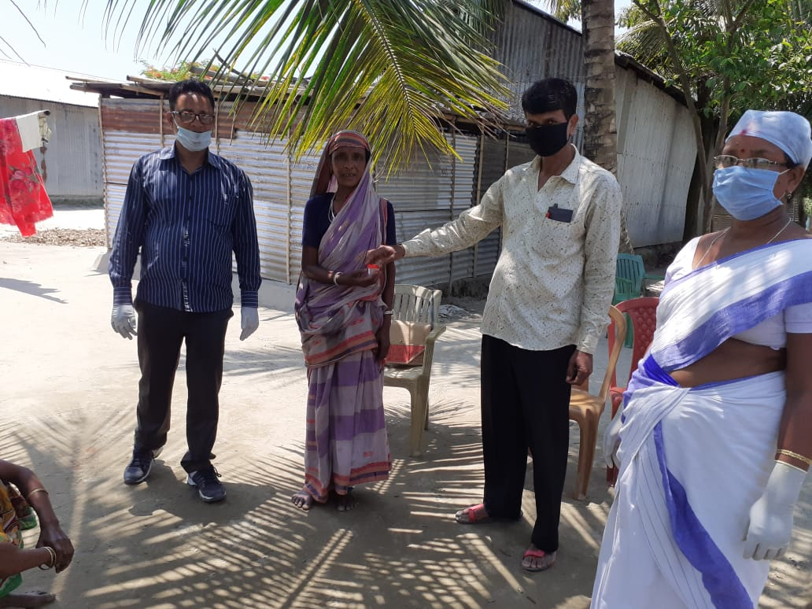
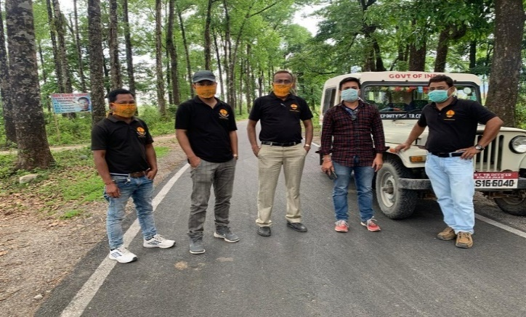

TB surveillance and sample collection along with the ongoing Community Surveillance Programme for Covid-19 (Nalbari district)
NTEP team of Kokrajhar district on field duty for drug distribution in a remote village bordering Bhutan

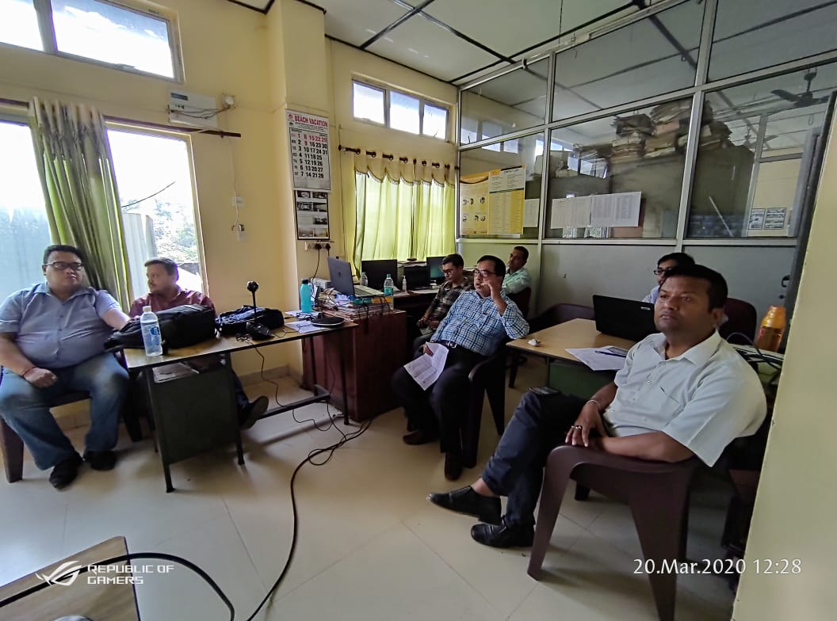
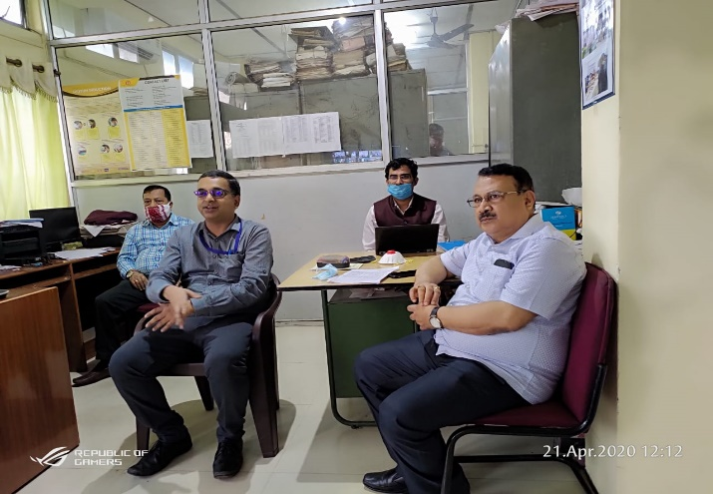

Commissioner & Secretary Health & FW Deptt., Govt. of Assam along with Director of Health Services, and Addl. DHS (SP) cum SPO, NTEP Assam along with STC Officials during a VC with District team

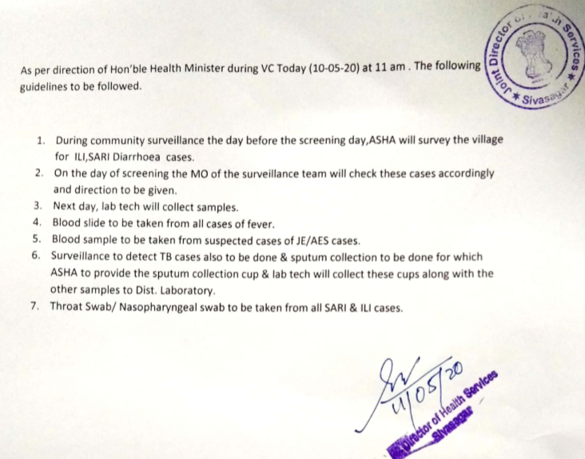

Order from Jt DHS of Sibsagar district on inclusion of TB surveillance and testing during Community surveillance for ILI and SARI for Covid response. All districts to follow similar activities.

